CMPSC 462 – Lab-3 (25 points)
Stack and Queue

Due date: in 1 week

Note: attach screenshots of your program and results under each programming exercises. Please make sure that the screenshot is readable. Don’t attach a very small screenshot image.

Lab Exercises:

- Show how to implement a Queue using two stacks?
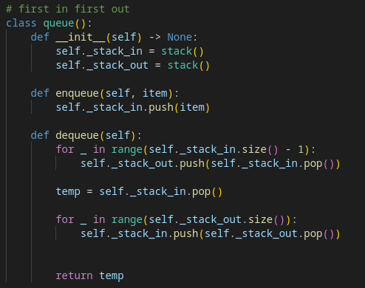

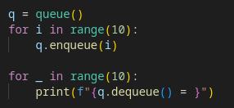

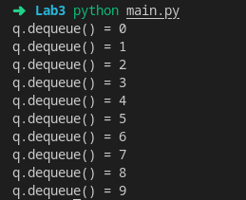

- Assume that you are not as careful programmer as you are and you frequently forget to close your brackets while you program - (, {, [ . You find it difficult to find where the mistake is. Write a program that reads in a sequence of characters, and determines whether its parentheses, braces, and curly braces are "balanced." Hint: for left delimiters, push onto stack; for right delimiters, pop from stack and check whether popped element matches right delimiter.
